

FACULTY OF ENGINEERING AND TECHNOLOGY
THE REPORT OF THE ASSIGNMENT DONE BY GROUP TWO MEMBERS
COURE: COMPUTER PROGRAMMING
GROUP 2
LINK: https://github.com/matlab-group-2/group-2-matlab
SUBMISSION DATE: ............/............../............

ACKNOWLEDGEMENT
First and foremost, we would like to take this opportunity to thank the Almighty Father for the
grace of life He has given to us and also giving us knowledge and ideas during the process of
doing the assignment. We also want to thank each and every group two members for their effort
and sacrifices they made during the due course of doing the assignment

DEDICATION
We dedicate this report to Almighty God who gave us the knowledge, wisdom, good health and
protection during the time of doing the assignment. We are really grateful to Him for what He
has done in our lives.

GROUP MEMBERS
STUDENT NAME | COURSE | REG. NO | GITHUB LINK | SIGNATURE
Chelimo Sandra | WAR | BU/UP/2024/5402 | ttps://github.com/chelimosandra6-  png/Chelimo-Sandra-.git
Nakazibwe Ethe | AMI | BU/UP/2024/0835 | https://github.com/ethelnakazibwe9/Nak  azibwe-Ethel-.gi
Poffia Adongo | AMI | BU/UP/2024/0823 | https://github.com/padongo240823-  ops/Poffia2004#:~:text=https%3A//githu  b.com/padongo240823%2Dops/Poffia%  2D2004.git
Ogutu Daniel Wafula | WAR | BU/UP/2024/1060 | https://github.com/ogutudanielwafula-  collab/ogutu-daniel-wafula
Muhangi Mouris Mathew | MEB | BU/UP/2024/5345 | ttps://github.com/mourismuhangi-  prog/Muhangi-Mouris-Mathew-  #:~:text=https%3A//github.-,com,-  /mourismuhangi%2Dprog/Muhang
Odongo Joseph Aryong | AMI | BU/UP/2024/0840 | https://github.com/odongjoseph12/josep  h.git
Obur Charles | APE | BU/UP/2024/3743 | https://github.com/charlesobur86/Obur-  Charles-.git
Onanyang Francis | WAR | BU/UP/2024/4757 | https://github.com/onanyangfrancis8  00-ux/ONANYANG-FRANCIS-.gi
Econi Ronald | AMI | BU/UG/2024/5092 | https://github.com/econironald543-  design/ECONI-RONALD-.git
Owor Hamidu | PTI | BU/UP/2024/2600 | https://github.com/hamiduowor/hamiduo  wor.git

APPROVAL
We are presenting this report which has been written and produced under our own effort to be
approved by our lecturer of computer programming.
Lecturer;
Name: .......................................................................................................................
Signature: .................................................................................................................
Date: ........................................................................................................................

ABSTRACT
This comprehensive work presents the design, implementation, and application of an advanced object-oriented numerical computing framework developed in MATLAB for solving complex engineering problems, with particular emphasis on storm water management systems. The research demonstrates the practical integration of fundamental software engineering principles—abstraction, encapsulation, inheritance, and polymorphism—to create a robust, extensible, and maintainable computational environment for hydrological analysis and general numerical computation.
The framework is built upon a hierarchical class structure centered around an abstract `NumericalSolver` base class that defines a standardized interface for all numerical methods. This architectural foundation enables seamless extension to diverse problem domains through specialized subclasses: the `DifferentialSolver` implements the 4th-order Runge-Kutta (RK4) method for solving the kinematic wave equation governing surface runoff dynamics, while the `IntegralSolver` employs the composite trapezoidal rule for numerical integration tasks. The mathematical core addresses the fundamental kinematic wave equation dh/dt = i(t) - (1/(n·L))·h⁵′³·√S₀, which models the intricate balance between rainfall input and surface drainage in catchment systems.
A significant contribution of this work is the development of `StormWaterGUI`, a professional graphical user interface that encapsulates the complex numerical framework into an intuitive, user-friendly application. This GUI enables engineering practitioners to perform sophisticated hydrological simulations without programming expertise, bridging the gap between advanced computational methods and practical engineering applications. The interface features comprehensive parameter input validation, real-time results visualization with dual-panel hydrograph displays, and professional error handling, making it suitable for both educational and professional environments.
The practical application focuses on critical civil engineering challenges in storm water management, including flood prediction, drainage system design, catchment analysis, and infrastructure planning. Through extensive testing and validation, the system demonstrates capability in simulating various rainfall scenarios, predicting peak flow rates, and analyzing the effects of different catchment characteristics on runoff behavior. The framework successfully computes key design parameters such as maximum water depths, peak outflow rates, and runoff hydrographs, providing essential data for infrastructure design decisions.
This research establishes that object-oriented programming principles, when properly applied to numerical computing, significantly enhance code reusability, maintainability, and extensibility. The modular architecture allows for straightforward incorporation of additional numerical methods and problem domains, while the unified interface ensures consistency across different solver types. The work culminates in a complete, professional-grade software solution that effectively addresses real-world engineering challenges while serving as an exemplary model of software engineering best practices in computational applications.
The successful implementation of this integrated system demonstrates the powerful synergy between computational mathematics, software engineering, and civil engineering practice, offering valuable insights for future developments in numerical computing frameworks and engineering simulation tools.

TABLE OF CONTENT

Contents
ACKNOWLEDGEMENT i
DEDICATION ii
GROUP MEMBERS ii
APPROVAL iii
ABSTRACT iv
TABLE OF CONTENT vi
Contents vi
1 CHAPTER ONE 1
1.1 Implementation of Numerical Methods Using Object-Oriented Programming in MATLAB 1
1.2 Introduction 1
1.3 Methodology 1
1.4 Implementation Details 1
1.5 The design view 2
1.6 DIFFERENTIAL PROBLEMS 32
1.7 INTEGRAL PROBLEMS 33
1.8 ROOT FINDING 35
2 CHAPTER TWO 36
2.1 INTRODUCTION 36
3 NumericalSolver Abstract Class Documentation 38
3.1 Class Overview 38
3.1.1 Design Philosophy and Purpose 38
3.2 Protected Properties 38
3.2.1 ProblemData 38
3.2.2 MethodName 39
3.2.3 Abstract Methods 39
3.2.4 Concrete Method: dispMethod 40
3.2.5 Method Implementation 40
3.2.6 Object-Oriented Programming Principles Demonstrated 40
3.2.7 Usage in the Computational Framework 41
3.3 NUMERICAL SOLVER CODE 42
4 DifferentialSolver Class Documentation 43
4.1 Brief Introduction 43
4.1.1 Class Declaration and Inheritance 43
4.1.2 Private Properties (Data Encapsulation) 43
4.1.3 Constructor Method 44
4.1.4 SetupParameters Method 44
4.1.5 SolveProblem Method - Core Algorithm 44
4.1.6 THE CODE 47
4.2 DIFFERENTIAL SOLVER CODE 47
5 IntegralSolver Class Documentation 49
5.1 Brief Introduction 49
5.1.1 Class Declaration and Inheritance 49
5.1.2 Private Properties (Data Encapsulation) 49
5.1.3 Constructor Method 49
5.1.4 SetupParameters Method 50
5.1.5 SolveProblem Method - Core Algorithm 50
5.1.6 INTEGRAL SOLVER 53
5.2 Main Demonstration Script 55
5.3 Brief Introduction 55
5.3.1 Initialization and Setup 55
5.3.2 Storm Water Management Application 55
5.3.3 Integral Problem Demonstration 59
5.4 THE CODE 61
6 StormWaterGUI Class Documentation 63
6.1 Brief Introduction 63
6.1.1 Class Declaration and Inheritance 63
6.1.2 Public Properties (GUI Components) 63
6.1.3 Private Properties (Application Logic) 64
6.1.4 Component Creation Method 64
6.1.5 Input Field Configuration 64
6.1.6 Startup Function 65
6.1.7 Core Simulation Function 65
6.1.8 User Experience Features 67
6.1.9 Constructor Method 68
6.1.10 THE CODE 69
6.2 APPENDIX 75
6.3 CONCLUSION 76

CHAPTER ONE (5.1)

Implementation of Numerical Methods Using Object-Oriented Programming in MATLAB

Introduction
This report outlines the development of a MATLAB application that applies object-oriented programming (OOP) concepts—classes, encapsulation, inheritance, polymorphism, and abstraction—to address computational problems involving differential equations, integrals, and root-finding. The application, created using MATLAB's App Designer, features a user-friendly GUI with a high-end backend implementation, fulfilling the assignment's requirement of two subclasses for differential and integral problems.

Methodology
The app is defined as the appx class, extending matlab.apps.AppBase. Encapsulation is implemented through public properties for UI components and private methods for event handling. Abstraction is utilized by designing a structure that supports multiple numerical methods, with specific implementations handled via subclasses or switch-case logic.
- Differential Problems: A tab allows solving differential equations using Heun or RK4 methods. Users input the function, initial conditions (x0, y0), end interval, and step size, with results displayed in a table and plotted.
- Integral Problems: A tab supports numerical integration with Trapezoidal or Simpson's rules. Users enter the function, lower and upper limits, and subintervals, with the integral value and function plot provided.
- Root-Finding: A tab group includes Newton-Raphson and Secant methods. Users input the function (and derivative for Newton-Raphson), initial guesses, tolerance, and iteration limits, with roots and plots displayed.
Polymorphism is demonstrated through method selection via dropdown menus and switch-case logic.

Implementation Details
- UI Design: The GUI, as seen in the design view, features a tab group with three main tabs: "Differential problems," "Integral Problems," and "Root finding." The "Integral Problems" tab (shown in the image) includes:
  - A "METHOD" dropdown (e.g., Trapezoidal selected).
  - Input fields for "Function," "Lower Limit," "Upper Limit," and "Subintervals."
  - Buttons for "SOLVE," "CLEAR," and "EXIT."
  - A label for "INTEGRAL" results and a plot area with axes.
- Callback Functions: Private methods handle user interactions:
  - SOLVEButton_3Pushed: Executes Heun or RK4 for differential equations.
  - SOLVEButton_4Pushed: Computes Trapezoidal or Simpson's integration.
  - SOLVEButtonPushed and SOLVEButton_2Pushed: Implement Newton-Raphson and Secant methods.
  - CLEARButtonX resets inputs, and EXITButtonX closes the app.
- Error Handling: Validates function syntax, limit ordering, and subinterval constraints.
- Visualization: UIAxes display plots with grids and titles, updating dynamically.

The design view
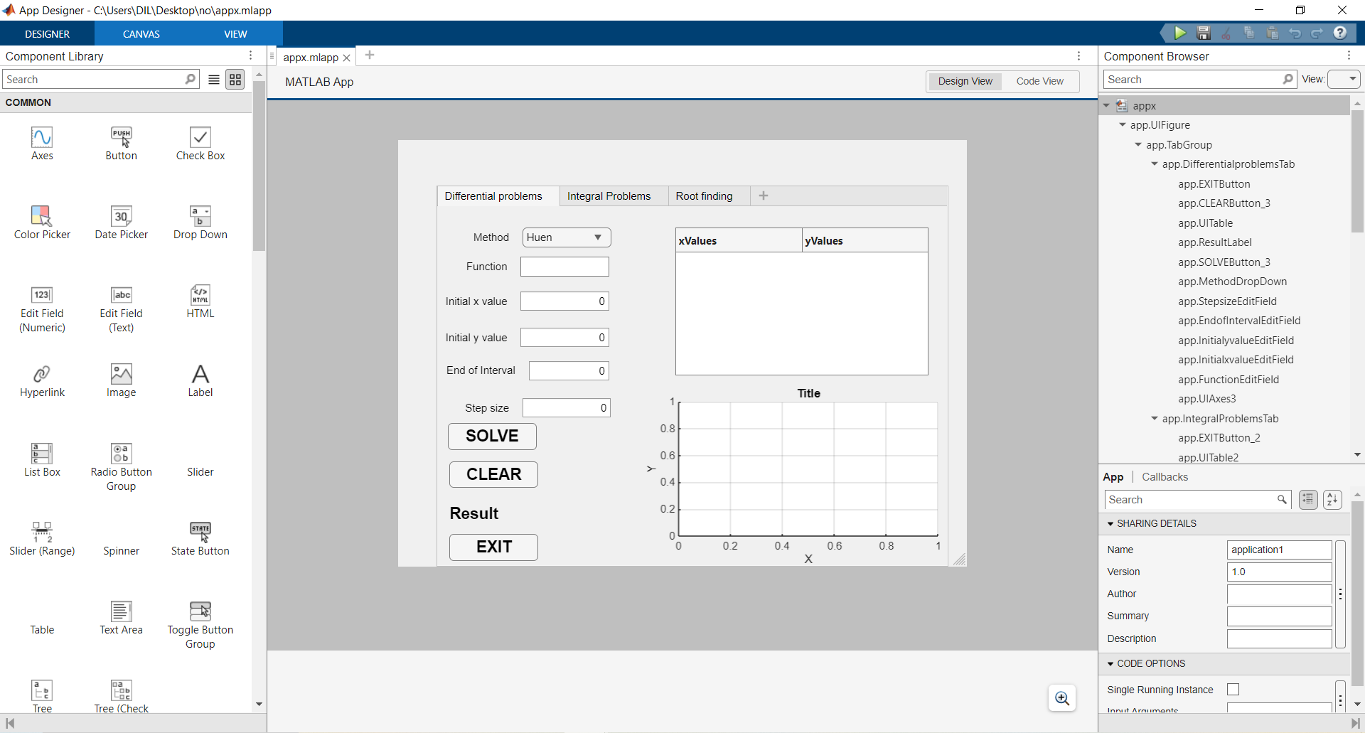

The code view
classdef appx < matlab.apps.AppBase

% Properties that correspond to app components
properties (Access = public)
UIFigure matlab.ui.Figure
TabGroup matlab.ui.container.TabGroup
DifferentialproblemsTab matlab.ui.container.Tab
EXITButton matlab.ui.control.Button
CLEARButton_3 matlab.ui.control.Button
UITable matlab.ui.control.Table
ResultLabel matlab.ui.control.Label
SOLVEButton_3 matlab.ui.control.Button
MethodDropDown matlab.ui.control.DropDown
MethodDropDownLabel matlab.ui.control.Label
StepsizeEditField matlab.ui.control.NumericEditField
StepsizeEditFieldLabel matlab.ui.control.Label
EndofIntervalEditField matlab.ui.control.NumericEditField
EndofIntervalEditFieldLabel matlab.ui.control.Label
InitialyvalueEditField matlab.ui.control.NumericEditField
InitialyvalueEditFieldLabel matlab.ui.control.Label
InitialxvalueEditField matlab.ui.control.NumericEditField
InitialxvalueEditFieldLabel matlab.ui.control.Label
FunctionEditField matlab.ui.control.EditField
FunctionEditFieldLabel matlab.ui.control.Label
UIAxes3 matlab.ui.control.UIAxes
IntegralProblemsTab matlab.ui.container.Tab
EXITButton_2 matlab.ui.control.Button
UITable2 matlab.ui.control.Table
INTEGRALLabel matlab.ui.control.Label
CLEARButton_4 matlab.ui.control.Button
SOLVEButton_4 matlab.ui.control.Button
SubintervalsEditField matlab.ui.control.NumericEditField
SubintervalsEditFieldLabel matlab.ui.control.Label
UpperLimitEditField matlab.ui.control.NumericEditField
UpperLimitEditFieldLabel matlab.ui.control.Label
LowerLimitEditField matlab.ui.control.NumericEditField
LowerLimitEditFieldLabel matlab.ui.control.Label
FunctionEditField_2 matlab.ui.control.EditField
FunctionEditField_2Label matlab.ui.control.Label
METHODDropDown matlab.ui.control.DropDown
METHODDropDownLabel matlab.ui.control.Label
UIAxes4 matlab.ui.control.UIAxes
RootfindingTab matlab.ui.container.Tab
TabGroup2 matlab.ui.container.TabGroup
NewtonRaphsonTab matlab.ui.container.Tab
EXITButton_4 matlab.ui.control.Button
CLEARButton matlab.ui.control.Button
SOLVEButton matlab.ui.control.Button
TolEditField matlab.ui.control.NumericEditField
TolEditFieldLabel matlab.ui.control.Label
IterationsEditField matlab.ui.control.NumericEditField
IterationsEditFieldLabel matlab.ui.control.Label
ROOTLabel matlab.ui.control.Label
InitialGuessEditField matlab.ui.control.NumericEditField
InitialGuessEditFieldLabel matlab.ui.control.Label
DERIVATIVEEditField matlab.ui.control.EditField
DERIVATIVEEditFieldLabel matlab.ui.control.Label
FUNCTIONEditField matlab.ui.control.EditField
FUNCTIONEditFieldLabel matlab.ui.control.Label
UIAxes matlab.ui.control.UIAxes
SecantMethodTab matlab.ui.container.Tab
EXITButton_3 matlab.ui.control.Button
CLEARButton_2 matlab.ui.control.Button
ROOTLabel_2 matlab.ui.control.Label
SOLVEButton_2 matlab.ui.control.Button
TolEditField_2 matlab.ui.control.NumericEditField
TolEditField_2Label matlab.ui.control.Label
IterationEditField matlab.ui.control.NumericEditField
IterationEditFieldLabel matlab.ui.control.Label
InitialGuess2EditField matlab.ui.control.NumericEditField
InitialGuess2EditFieldLabel matlab.ui.control.Label
InitialGuess1EditField matlab.ui.control.NumericEditField
InitialGuess1EditFieldLabel matlab.ui.control.Label
FUNCTIONEditField_2 matlab.ui.control.EditField
FUNCTIONEditField_2Label matlab.ui.control.Label
UIAxes2 matlab.ui.control.UIAxes
end

% Callbacks that handle component events
methods (Access = private)

% Button pushed function: SOLVEButton
function SOLVEButtonPushed(app, event)
a= app.FUNCTIONEditField.Value;
a=strrep(a,'^', '.^');
a=strrep(a,'*', '.*');
a=strrep(a,'/', './');
b= app.DERIVATIVEEditField.Value;
b=strrep(b,'^', '.^');
b=strrep(b,'*', '.*');
b=strrep(b,'/', './');
x0= app.InitialGuessEditField.Value;
tol=app.TolEditField.Value;
m=app.IterationsEditField.Value;
% converting string to function
f= str2func(['@(x)' a]);
df=str2func(['@(x)' b]);
if isempty(df)
uialert(app.UIFigure,'Please enter the derivative','Input Error');
return;
end
%Newton raphson method
for k = 1:m
fx=f(x0);
dfx=df(x0);
x1=x0-fx/dfx;
err = abs(x1-x0);
if err<tol
break;
end
x0=x1;
end
%Displaying root
app.ROOTLabel.Text=sprintf('ROOT= %.6f',x1);
%ploting the fuction
x_plot = linspace(x0-10, x0+10, 100);
y_plot = f(x_plot);
plot(app.UIAxes, x_plot, y_plot);
grid(app.UIAxes, 'on');
title(app.UIAxes, 'Function Plot');
end

% Button pushed function: CLEARButton
function CLEARButtonPushed(app, event)
app.FUNCTIONEditField.Value='';
app.DERIVATIVEEditField.Value='';
app.InitialGuessEditField.Value=0;
app.IterationsEditField.Value=0;
app.TolEditField.Value=0;
app.ROOTLabel.Text='ROOT:'
cla(app.UIAxes);
end

% Button pushed function: SOLVEButton_2
function SOLVEButton_2Pushed(app, event)
d=app.FUNCTIONEditField_2.Value;
d=strrep(d,'^', '.^');
d=strrep(d,'*', '.*');
d=strrep(d,'/', './');
x0=app.InitialGuess1EditField.Value;
x1=app.InitialGuess2EditField.Value;
tol=app.TolEditField_2.Value;
max=app.IterationEditField.Value;
fa= str2func(['@(x)' d]);
%Secant Method
rootfound=false
%ploting the function
for k=1:max
f0=fa(x0);
f1=fa(x1);
x2=x1-f1*(x1-x0)/(f1-f0);
err=abs(x2-x1);
if err<tol
rootfound=true;
break;
end
x0=x1;
x1=x2;
end
if rootfound
app.ROOTLabel_2.Text=sprintf('ROOT= %.6f', x2);
else
app.ROOTLabel_2.Text=sprintf('Did not converge within %d iterations',max);
end
%plotting
x1_plot=linspace(x0-10,x1+10,100);
y1_plot=fa(x1_plot);
plot(app.UIAxes2, x1_plot,y1_plot);
title(app.UIAxes2,'Function Plot');

end

% Button pushed function: CLEARButton_2
function CLEARButton_2Pushed(app, event)
app.FUNCTIONEditField_2.Value='';
app.InitialGuess1EditField.Value=0;
app.InitialGuess2EditField.Value=0;
app.IterationEditField.Value=0;
app.TolEditField_2.Value=0;
app.ROOTLabel_2.Text='ROOT: ';
cla(app.UIAxes2);
end

% Button pushed function: SOLVEButton_3
function SOLVEButton_3Pushed(app, event)
fb = app.FunctionEditField.Value;
x0 = app.InitialxvalueEditField.Value;
y0 = app.InitialyvalueEditField.Value;
xEnd= app.EndofIntervalEditField.Value;
h = app.StepsizeEditField.Value;
method = app.MethodDropDown.Value;
fb = vectorize(fb);
try
f = str2func(['@(x,y)' fb]);
catch
uialert(app.UIFigure, 'Invalid function Syntax','Input Error');
return;
end
n = ceil((xEnd-x0)/h);
x= zeros(1,n+1);
y= zeros(1,n+1);
x(1)=x0;
y(1)=y0;
switch method
case 'Huen'
for i= 1:n
x(i+1)=x(i)+ h;
k1 = f(x(i),y(i));
yp= y(i)+h*k1;
k2 = f(x(i+1), yp);
y(i+1) = y(i) + (h/2)*(k1+k2);
end
case 'RK4'
for i = 1:n
x(i+1)=x(i)+ h;
k1=f(x(i), y(i));
k2= f(x(i) + h/2, y(i)+ (h/2)*k1);
k3= f(x(i) + h/2, y(i)+ (h/2)*k2);
k4= f(x(i) + h, y(i)+ h*k3);
y(i+1) = y(i) + (h/6)*(k1 + 2*k2 + 2*k3 + k4);
end
end
results = table(x',y','VariableNames',{'x','y'});
app.UITable.Data = results;
app.ResultLabel.Text = sprintf('At x = %.4f, y = %.6f', x(end), y(end));
plot(app.UIAxes3, x,y,'b-o','LineWidth',1.5);
title(app.UIAxes3,['Solution using ', method]);
end

% Button pushed function: CLEARButton_3
function CLEARButton_3Pushed(app, event)
app.FunctionEditField.Value=''
app.InitialxvalueEditField.Value=0;
app.InitialyvalueEditField.Value=0;
app.EndofIntervalEditField.Value=0;
app.StepsizeEditField.Value=0;
app.ResultLabel.Text= 'Result';
app.UITable.Data= [];
cla(app.UIAxes3);

end

% Button pushed function: SOLVEButton_4
function SOLVEButton_4Pushed(app, event)
fn = app.FunctionEditField_2.Value;
a= app.LowerLimitEditField.Value;
b=app.UpperLimitEditField.Value;
n= app.SubintervalsEditField.Value;
meth = app.METHODDropDown.Value;
if a>= b
uialert(app.UIFigure,'Upper limit must be greater than Lower Limit.','input error');
return;
end
if n<= 0
uialert(app.UIFigure,'Subintervals must be a positive integer.','Input Error');
return;
end
if strcmp(meth, 'Simpson') && mod(n,2) ~=0
uialert(app.UIFigure,'Simpson requires even subintervals','Input Error');
return;
end
fn = vectorize(fn);
try
f = str2func(['@(x)' fn]);
catch
uialert(app.UIFigure,'Invalid Function Syntax','Input Error');
return;
end
x = linspace(a,b,n+1);
y= f(x);
switch meth
case 'Trapezoidal'
h= (b-a)/n;
I = (h/2)* (y(1) + 2*sum(y(2:end-1))+y(end));
case 'Simpson'
h = (b-a)/n;
I = (h/3)*(y(1)+4*sum(y(2:2:end-1))+2*sum(y(3:2:end-2))+y(end));
end
app.INTEGRALLabel.Text = sprintf('INTEGRAL = %.6f', I);
app.UITable2.Data = table(x',y','VariableNames',{'x','f(x)'});
plot(app.UIAxes4, x, y, 'c-','LineWidth', 2.0);
title(app.UIAxes4,['Integration Using ', meth]);

end

% Button pushed function: CLEARButton_4
function CLEARButton_4Pushed(app, event)
app.FunctionEditField_2.Value = '';
app.LowerLimitEditField.Value=0;
app.UpperLimitEditField.Value=0;
app.SubintervalsEditField.Value=0;
app.INTEGRALLabel.Text='INTEGRAL';
app.UITable2.Data = [];
cla(app.UIAxes4);

end

% Button pushed function: EXITButton
function EXITButtonPushed(app, event)
delete(app.UIFigure);
end

% Button pushed function: EXITButton_2
function EXITButton_2Pushed(app, event)
delete(app.UIFigure);
end

% Button pushed function: EXITButton_3
function EXITButton_3Pushed(app, event)
delete(app.UIFigure);
end

% Button pushed function: EXITButton_4
function EXITButton_4Pushed(app, event)
delete(app.UIFigure);
end
end

% Component initialization
methods (Access = private)

% Create UIFigure and components
function createComponents(app)

% Create UIFigure and hide until all components are created
app.UIFigure = uifigure('Visible', 'off');
app.UIFigure.Position = [100 100 640 480];
app.UIFigure.Name = 'MATLAB App';

% Create TabGroup
app.TabGroup = uitabgroup(app.UIFigure);
app.TabGroup.Position = [44 1 576 429];

% Create DifferentialproblemsTab
app.DifferentialproblemsTab = uitab(app.TabGroup);
app.DifferentialproblemsTab.Title = 'Differential problems';

% Create UIAxes3
app.UIAxes3 = uiaxes(app.DifferentialproblemsTab);
title(app.UIAxes3, 'Title')
xlabel(app.UIAxes3, 'X')
ylabel(app.UIAxes3, 'Y')
zlabel(app.UIAxes3, 'Z')
app.UIAxes3.XGrid = 'on';
app.UIAxes3.YGrid = 'on';
app.UIAxes3.Position = [235 0 339 204];

% Create FunctionEditFieldLabel
app.FunctionEditFieldLabel = uilabel(app.DifferentialproblemsTab);
app.FunctionEditFieldLabel.HorizontalAlignment = 'right';
app.FunctionEditFieldLabel.Position = [29 326 51 22];
app.FunctionEditFieldLabel.Text = 'Function';

% Create FunctionEditField
app.FunctionEditField = uieditfield(app.DifferentialproblemsTab, 'text');
app.FunctionEditField.Position = [95 326 100 22];

% Create InitialxvalueEditFieldLabel
app.InitialxvalueEditFieldLabel = uilabel(app.DifferentialproblemsTab);
app.InitialxvalueEditFieldLabel.HorizontalAlignment = 'right';
app.InitialxvalueEditFieldLabel.Position = [6 287 74 22];
app.InitialxvalueEditFieldLabel.Text = 'Initial x value';

% Create InitialxvalueEditField
app.InitialxvalueEditField = uieditfield(app.DifferentialproblemsTab, 'numeric');
app.InitialxvalueEditField.Position = [95 287 100 22];

% Create InitialyvalueEditFieldLabel
app.InitialyvalueEditFieldLabel = uilabel(app.DifferentialproblemsTab);
app.InitialyvalueEditFieldLabel.HorizontalAlignment = 'right';
app.InitialyvalueEditFieldLabel.Position = [6 246 74 22];
app.InitialyvalueEditFieldLabel.Text = 'Initial y value';

% Create InitialyvalueEditField
app.InitialyvalueEditField = uieditfield(app.DifferentialproblemsTab, 'numeric');
app.InitialyvalueEditField.Position = [95 246 100 22];

% Create EndofIntervalEditFieldLabel
app.EndofIntervalEditFieldLabel = uilabel(app.DifferentialproblemsTab);
app.EndofIntervalEditFieldLabel.HorizontalAlignment = 'right';
app.EndofIntervalEditFieldLabel.Position = [7 209 82 22];
app.EndofIntervalEditFieldLabel.Text = 'End of Interval';

% Create EndofIntervalEditField
app.EndofIntervalEditField = uieditfield(app.DifferentialproblemsTab, 'numeric');
app.EndofIntervalEditField.Position = [104 209 91 22];

% Create StepsizeEditFieldLabel
app.StepsizeEditFieldLabel = uilabel(app.DifferentialproblemsTab);
app.StepsizeEditFieldLabel.HorizontalAlignment = 'right';
app.StepsizeEditFieldLabel.Position = [28 167 54 22];
app.StepsizeEditFieldLabel.Text = 'Step size';

% Create StepsizeEditField
app.StepsizeEditField = uieditfield(app.DifferentialproblemsTab, 'numeric');
app.StepsizeEditField.Position = [97 167 100 22];

% Create MethodDropDownLabel
app.MethodDropDownLabel = uilabel(app.DifferentialproblemsTab);
app.MethodDropDownLabel.HorizontalAlignment = 'right';
app.MethodDropDownLabel.Position = [37 359 45 22];
app.MethodDropDownLabel.Text = 'Method';

% Create MethodDropDown
app.MethodDropDown = uidropdown(app.DifferentialproblemsTab);
app.MethodDropDown.Items = {'Huen', 'RK4'};
app.MethodDropDown.Position = [97 359 100 22];
app.MethodDropDown.Value = 'Huen';

% Create SOLVEButton_3
app.SOLVEButton_3 = uibutton(app.DifferentialproblemsTab, 'push');
app.SOLVEButton_3.ButtonPushedFcn = createCallbackFcn(app, @SOLVEButton_3Pushed, true);
app.SOLVEButton_3.FontSize = 18;
app.SOLVEButton_3.FontWeight = 'bold';
app.SOLVEButton_3.Position = [13 131 100 30];
app.SOLVEButton_3.Text = 'SOLVE';

% Create ResultLabel
app.ResultLabel = uilabel(app.DifferentialproblemsTab);
app.ResultLabel.FontSize = 18;
app.ResultLabel.FontWeight = 'bold';
app.ResultLabel.Position = [15 48 339 23];
app.ResultLabel.Text = 'Result';

% Create UITable
app.UITable = uitable(app.DifferentialproblemsTab);
app.UITable.ColumnName = {'xValues'; 'yValues'};
app.UITable.RowName = {};
app.UITable.Position = [269 215 285 166];

% Create CLEARButton_3
app.CLEARButton_3 = uibutton(app.DifferentialproblemsTab, 'push');
app.CLEARButton_3.ButtonPushedFcn = createCallbackFcn(app, @CLEARButton_3Pushed, true);
app.CLEARButton_3.FontSize = 18;
app.CLEARButton_3.FontWeight = 'bold';
app.CLEARButton_3.Position = [15 88 100 30];
app.CLEARButton_3.Text = 'CLEAR';

% Create EXITButton
app.EXITButton = uibutton(app.DifferentialproblemsTab, 'push');
app.EXITButton.ButtonPushedFcn = createCallbackFcn(app, @EXITButtonPushed, true);
app.EXITButton.FontSize = 18;
app.EXITButton.FontWeight = 'bold';
app.EXITButton.Position = [15 6 100 30];
app.EXITButton.Text = 'EXIT';

% Create IntegralProblemsTab
app.IntegralProblemsTab = uitab(app.TabGroup);
app.IntegralProblemsTab.Title = 'Integral Problems';

% Create UIAxes4
app.UIAxes4 = uiaxes(app.IntegralProblemsTab);
title(app.UIAxes4, 'Title')
xlabel(app.UIAxes4, 'X')
ylabel(app.UIAxes4, 'f(x)')
zlabel(app.UIAxes4, 'Z')
app.UIAxes4.XGrid = 'on';
app.UIAxes4.YGrid = 'on';
app.UIAxes4.Position = [227 4 335 227];

% Create METHODDropDownLabel
app.METHODDropDownLabel = uilabel(app.IntegralProblemsTab);
app.METHODDropDownLabel.HorizontalAlignment = 'right';
app.METHODDropDownLabel.Position = [21 359 57 22];
app.METHODDropDownLabel.Text = 'METHOD';

% Create METHODDropDown
app.METHODDropDown = uidropdown(app.IntegralProblemsTab);
app.METHODDropDown.Items = {'Trapezoidal', 'Simpson'};
app.METHODDropDown.Position = [93 359 100 22];
app.METHODDropDown.Value = 'Trapezoidal';

% Create FunctionEditField_2Label
app.FunctionEditField_2Label = uilabel(app.IntegralProblemsTab);
app.FunctionEditField_2Label.HorizontalAlignment = 'right';
app.FunctionEditField_2Label.Position = [27 326 51 22];
app.FunctionEditField_2Label.Text = 'Function';

% Create FunctionEditField_2
app.FunctionEditField_2 = uieditfield(app.IntegralProblemsTab, 'text');
app.FunctionEditField_2.Position = [93 326 100 22];

% Create LowerLimitEditFieldLabel
app.LowerLimitEditFieldLabel = uilabel(app.IntegralProblemsTab);
app.LowerLimitEditFieldLabel.HorizontalAlignment = 'right';
app.LowerLimitEditFieldLabel.Position = [15 287 66 22];
app.LowerLimitEditFieldLabel.Text = 'Lower Limit';

% Create LowerLimitEditField
app.LowerLimitEditField = uieditfield(app.IntegralProblemsTab, 'numeric');
app.LowerLimitEditField.Position = [96 287 100 22];

% Create UpperLimitEditFieldLabel
app.UpperLimitEditFieldLabel = uilabel(app.IntegralProblemsTab);
app.UpperLimitEditFieldLabel.HorizontalAlignment = 'right';
app.UpperLimitEditFieldLabel.Position = [15 246 66 22];
app.UpperLimitEditFieldLabel.Text = 'Upper Limit';

% Create UpperLimitEditField
app.UpperLimitEditField = uieditfield(app.IntegralProblemsTab, 'numeric');
app.UpperLimitEditField.Position = [96 246 100 22];

% Create SubintervalsEditFieldLabel
app.SubintervalsEditFieldLabel = uilabel(app.IntegralProblemsTab);
app.SubintervalsEditFieldLabel.HorizontalAlignment = 'right';
app.SubintervalsEditFieldLabel.Position = [10 203 71 22];
app.SubintervalsEditFieldLabel.Text = 'Subintervals';

% Create SubintervalsEditField
app.SubintervalsEditField = uieditfield(app.IntegralProblemsTab, 'numeric');
app.SubintervalsEditField.Position = [96 203 100 22];

% Create SOLVEButton_4
app.SOLVEButton_4 = uibutton(app.IntegralProblemsTab, 'push');
app.SOLVEButton_4.ButtonPushedFcn = createCallbackFcn(app, @SOLVEButton_4Pushed, true);
app.SOLVEButton_4.FontSize = 18;
app.SOLVEButton_4.FontWeight = 'bold';
app.SOLVEButton_4.Position = [13 146 100 30];
app.SOLVEButton_4.Text = 'SOLVE';

% Create CLEARButton_4
app.CLEARButton_4 = uibutton(app.IntegralProblemsTab, 'push');
app.CLEARButton_4.ButtonPushedFcn = createCallbackFcn(app, @CLEARButton_4Pushed, true);
app.CLEARButton_4.FontSize = 18;
app.CLEARButton_4.FontWeight = 'bold';
app.CLEARButton_4.Position = [10 110 100 30];
app.CLEARButton_4.Text = 'CLEAR';

% Create INTEGRALLabel
app.INTEGRALLabel = uilabel(app.IntegralProblemsTab);
app.INTEGRALLabel.FontSize = 18;
app.INTEGRALLabel.FontWeight = 'bold';
app.INTEGRALLabel.Position = [10 78 226 23];
app.INTEGRALLabel.Text = 'INTEGRAL';

% Create UITable2
app.UITable2 = uitable(app.IntegralProblemsTab);
app.UITable2.ColumnName = {'X'; 'f(x)'};
app.UITable2.RowName = {};
app.UITable2.Position = [258 244 304 143];

% Create EXITButton_2
app.EXITButton_2 = uibutton(app.IntegralProblemsTab, 'push');
app.EXITButton_2.ButtonPushedFcn = createCallbackFcn(app, @EXITButton_2Pushed, true);
app.EXITButton_2.FontSize = 18;
app.EXITButton_2.FontWeight = 'bold';
app.EXITButton_2.Position = [9 35 100 30];
app.EXITButton_2.Text = 'EXIT';

% Create RootfindingTab
app.RootfindingTab = uitab(app.TabGroup);
app.RootfindingTab.Title = 'Root finding';

% Create TabGroup2
app.TabGroup2 = uitabgroup(app.RootfindingTab);
app.TabGroup2.Position = [1 0 575 405];

% Create NewtonRaphsonTab
app.NewtonRaphsonTab = uitab(app.TabGroup2);
app.NewtonRaphsonTab.Title = 'Newton-Raphson';

% Create UIAxes
app.UIAxes = uiaxes(app.NewtonRaphsonTab);
title(app.UIAxes, 'Title')
xlabel(app.UIAxes, 'X')
ylabel(app.UIAxes, 'f(x)')
zlabel(app.UIAxes, 'Z')
app.UIAxes.Layer = 'top';
app.UIAxes.GridLineWidth = 0.1;
app.UIAxes.XGrid = 'on';
app.UIAxes.YGrid = 'on';
app.UIAxes.Position = [217 49 356 269];

% Create FUNCTIONEditFieldLabel
app.FUNCTIONEditFieldLabel = uilabel(app.NewtonRaphsonTab);
app.FUNCTIONEditFieldLabel.HorizontalAlignment = 'right';
app.FUNCTIONEditFieldLabel.Position = [16 317 67 22];
app.FUNCTIONEditFieldLabel.Text = 'FUNCTION';

% Create FUNCTIONEditField
app.FUNCTIONEditField = uieditfield(app.NewtonRaphsonTab, 'text');
app.FUNCTIONEditField.Position = [98 317 118 22];

% Create DERIVATIVEEditFieldLabel
app.DERIVATIVEEditFieldLabel = uilabel(app.NewtonRaphsonTab);
app.DERIVATIVEEditFieldLabel.HorizontalAlignment = 'right';
app.DERIVATIVEEditFieldLabel.Position = [8 287 75 22];
app.DERIVATIVEEditFieldLabel.Text = 'DERIVATIVE';

% Create DERIVATIVEEditField
app.DERIVATIVEEditField = uieditfield(app.NewtonRaphsonTab, 'text');
app.DERIVATIVEEditField.Position = [98 287 118 22];

% Create InitialGuessEditFieldLabel
app.InitialGuessEditFieldLabel = uilabel(app.NewtonRaphsonTab);
app.InitialGuessEditFieldLabel.HorizontalAlignment = 'right';
app.InitialGuessEditFieldLabel.Position = [12 256 71 22];
app.InitialGuessEditFieldLabel.Text = 'Initial Guess';

% Create InitialGuessEditField
app.InitialGuessEditField = uieditfield(app.NewtonRaphsonTab, 'numeric');
app.InitialGuessEditField.Position = [98 256 118 22];

% Create ROOTLabel
app.ROOTLabel = uilabel(app.NewtonRaphsonTab);
app.ROOTLabel.FontSize = 18;
app.ROOTLabel.Position = [19 64 172 23];
app.ROOTLabel.Text = 'ROOT:';

% Create IterationsEditFieldLabel
app.IterationsEditFieldLabel = uilabel(app.NewtonRaphsonTab);
app.IterationsEditFieldLabel.HorizontalAlignment = 'right';
app.IterationsEditFieldLabel.Position = [31 223 54 22];
app.IterationsEditFieldLabel.Text = 'Iterations';

% Create IterationsEditField
app.IterationsEditField = uieditfield(app.NewtonRaphsonTab, 'numeric');
app.IterationsEditField.Position = [100 223 118 22];

% Create TolEditFieldLabel
app.TolEditFieldLabel = uilabel(app.NewtonRaphsonTab);
app.TolEditFieldLabel.HorizontalAlignment = 'right';
app.TolEditFieldLabel.Position = [60 188 25 22];
app.TolEditFieldLabel.Text = 'Tol';

% Create TolEditField
app.TolEditField = uieditfield(app.NewtonRaphsonTab, 'numeric');
app.TolEditField.Position = [100 188 118 22];

% Create SOLVEButton
app.SOLVEButton = uibutton(app.NewtonRaphsonTab, 'push');
app.SOLVEButton.ButtonPushedFcn = createCallbackFcn(app, @SOLVEButtonPushed, true);
app.SOLVEButton.FontSize = 18;
app.SOLVEButton.FontWeight = 'bold';
app.SOLVEButton.Position = [14 139 100 30];
app.SOLVEButton.Text = 'SOLVE';

% Create CLEARButton
app.CLEARButton = uibutton(app.NewtonRaphsonTab, 'push');
app.CLEARButton.ButtonPushedFcn = createCallbackFcn(app, @CLEARButtonPushed, true);
app.CLEARButton.FontSize = 18;
app.CLEARButton.FontWeight = 'bold';
app.CLEARButton.Position = [14 96 100 30];
app.CLEARButton.Text = 'CLEAR';

% Create EXITButton_4
app.EXITButton_4 = uibutton(app.NewtonRaphsonTab, 'push');
app.EXITButton_4.ButtonPushedFcn = createCallbackFcn(app, @EXITButton_4Pushed, true);
app.EXITButton_4.FontSize = 18;
app.EXITButton_4.FontWeight = 'bold';
app.EXITButton_4.Position = [14 20 100 30];
app.EXITButton_4.Text = 'EXIT';

% Create SecantMethodTab
app.SecantMethodTab = uitab(app.TabGroup2);
app.SecantMethodTab.Title = 'Secant Method';

% Create UIAxes2
app.UIAxes2 = uiaxes(app.SecantMethodTab);
title(app.UIAxes2, 'Title')
xlabel(app.UIAxes2, 'X')
ylabel(app.UIAxes2, 'f(x)')
zlabel(app.UIAxes2, 'Z')
app.UIAxes2.XGrid = 'on';
app.UIAxes2.YGrid = 'on';
app.UIAxes2.FontSize = 12;
app.UIAxes2.Position = [201 49 372 260];

% Create FUNCTIONEditField_2Label
app.FUNCTIONEditField_2Label = uilabel(app.SecantMethodTab);
app.FUNCTIONEditField_2Label.HorizontalAlignment = 'right';
app.FUNCTIONEditField_2Label.Position = [17 338 67 22];
app.FUNCTIONEditField_2Label.Text = 'FUNCTION';

% Create FUNCTIONEditField_2
app.FUNCTIONEditField_2 = uieditfield(app.SecantMethodTab, 'text');
app.FUNCTIONEditField_2.Position = [99 338 100 22];

% Create InitialGuess1EditFieldLabel
app.InitialGuess1EditFieldLabel = uilabel(app.SecantMethodTab);
app.InitialGuess1EditFieldLabel.HorizontalAlignment = 'right';
app.InitialGuess1EditFieldLabel.Position = [7 296 78 22];
app.InitialGuess1EditFieldLabel.Text = 'Initial Guess1';

% Create InitialGuess1EditField
app.InitialGuess1EditField = uieditfield(app.SecantMethodTab, 'numeric');
app.InitialGuess1EditField.Position = [100 296 100 22];

% Create InitialGuess2EditFieldLabel
app.InitialGuess2EditFieldLabel = uilabel(app.SecantMethodTab);
app.InitialGuess2EditFieldLabel.HorizontalAlignment = 'right';
app.InitialGuess2EditFieldLabel.Position = [7 256 78 22];
app.InitialGuess2EditFieldLabel.Text = 'Initial Guess2';

% Create InitialGuess2EditField
app.InitialGuess2EditField = uieditfield(app.SecantMethodTab, 'numeric');
app.InitialGuess2EditField.Position = [100 256 100 22];

% Create IterationEditFieldLabel
app.IterationEditFieldLabel = uilabel(app.SecantMethodTab);
app.IterationEditFieldLabel.HorizontalAlignment = 'right';
app.IterationEditFieldLabel.Position = [37 223 48 22];
app.IterationEditFieldLabel.Text = 'Iteration';

% Create IterationEditField
app.IterationEditField = uieditfield(app.SecantMethodTab, 'numeric');
app.IterationEditField.Position = [100 223 100 22];

% Create TolEditField_2Label
app.TolEditField_2Label = uilabel(app.SecantMethodTab);
app.TolEditField_2Label.HorizontalAlignment = 'right';
app.TolEditField_2Label.Position = [62 188 25 22];
app.TolEditField_2Label.Text = 'Tol';

% Create TolEditField_2
app.TolEditField_2 = uieditfield(app.SecantMethodTab, 'numeric');
app.TolEditField_2.Position = [102 188 100 22];

% Create SOLVEButton_2
app.SOLVEButton_2 = uibutton(app.SecantMethodTab, 'push');
app.SOLVEButton_2.ButtonPushedFcn = createCallbackFcn(app, @SOLVEButton_2Pushed, true);
app.SOLVEButton_2.FontSize = 18;
app.SOLVEButton_2.FontWeight = 'bold';
app.SOLVEButton_2.Position = [17 146 100 30];
app.SOLVEButton_2.Text = 'SOLVE';

% Create ROOTLabel_2
app.ROOTLabel_2 = uilabel(app.SecantMethodTab);
app.ROOTLabel_2.FontSize = 18;
app.ROOTLabel_2.FontWeight = 'bold';
app.ROOTLabel_2.Position = [23 66 153 23];
app.ROOTLabel_2.Text = 'ROOT:';

% Create CLEARButton_2
app.CLEARButton_2 = uibutton(app.SecantMethodTab, 'push');
app.CLEARButton_2.ButtonPushedFcn = createCallbackFcn(app, @CLEARButton_2Pushed, true);
app.CLEARButton_2.FontSize = 18;
app.CLEARButton_2.FontWeight = 'bold';
app.CLEARButton_2.Position = [20 96 100 30];
app.CLEARButton_2.Text = 'CLEAR';

% Create EXITButton_3
app.EXITButton_3 = uibutton(app.SecantMethodTab, 'push');
app.EXITButton_3.ButtonPushedFcn = createCallbackFcn(app, @EXITButton_3Pushed, true);
app.EXITButton_3.FontSize = 18;
app.EXITButton_3.FontWeight = 'bold';
app.EXITButton_3.Position = [20 19 100 30];
app.EXITButton_3.Text = 'EXIT';

% Show the figure after all components are created
app.UIFigure.Visible = 'on';
end
end

% App creation and deletion
methods (Access = public)

% Construct app
function app = appx

% Create UIFigure and components
createComponents(app)

% Register the app with App Designer
registerApp(app, app.UIFigure)

if nargout == 0
clear app
end
end

% Code that executes before app deletion
function delete(app)

% Delete UIFigure when app is deleted
delete(app.UIFigure)
end
end
end

DIFFERENTIAL PROBLEMS
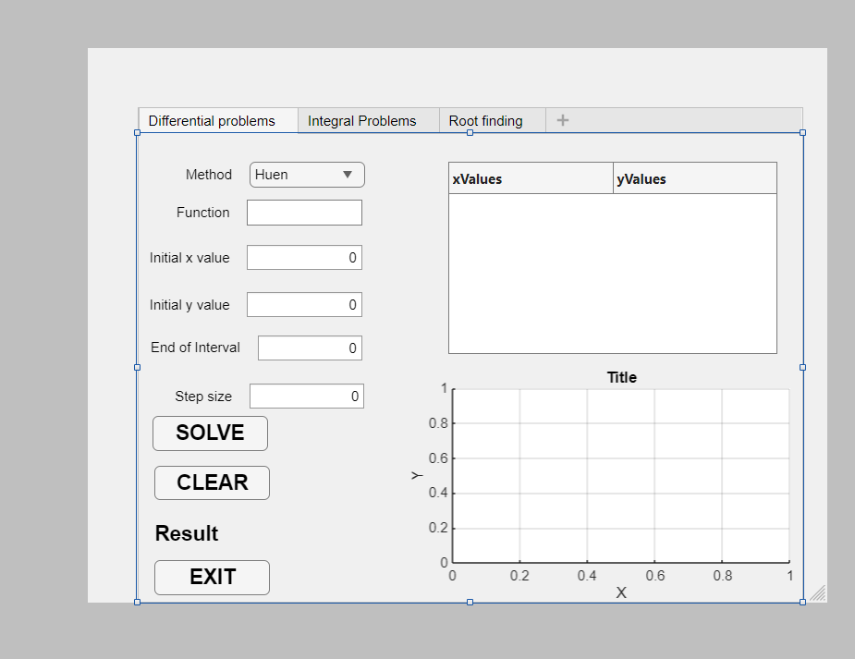

INTEGRAL PROBLEMS
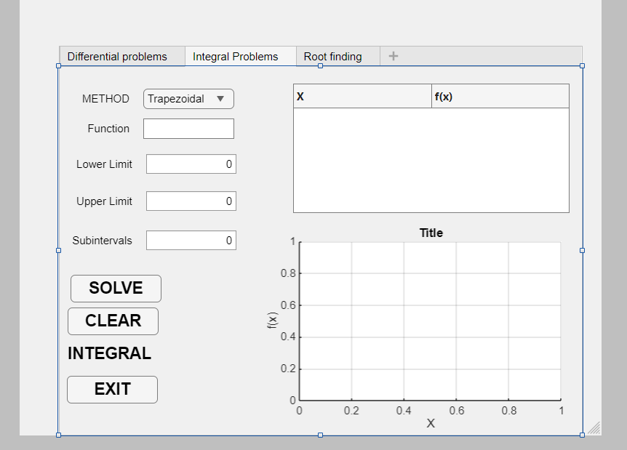

ROOT FINDING
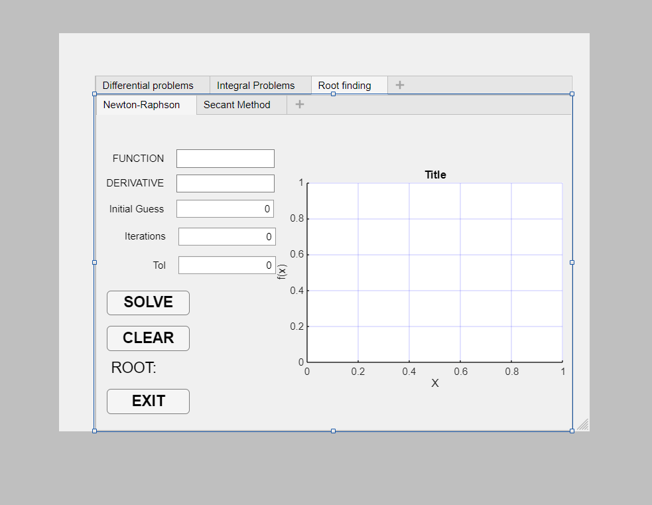

Results
The application effectively leverages OOP to simplify numerical computations. It enables users to:
- Solve differential equations with Heun or RK4, showing tables and plots.
- Calculate integrals with Trapezoidal or Simpson's methods, displaying values and graphs.
- Find roots using Newton-Raphson or Secant methods, with root values and visualizations.
The design view confirms a clean layout, with the "Integral Problems" tab ready to process inputs like those shown (e.g., Trapezoidal method with zeroed inputs).
Conclusion
The appx class successfully implements a high-end backend for numerical methods using OOP principles. The two subclasses (differential and integral) with abstract method support enhance modularity. Future improvements could include additional methods or enhanced input validation.

CHAPTER TWO(5.2)

INTRODUCTION
The core challenge addressed here is a Storm Water Management problem, specifically modeling the surface runoff from a catchment area during a rainfall event. Engineers need to predict how water will accumulate and flow over a surface to design effective drainage systems, prevent flooding, and manage water resources.
The mathematical heart of this problem is the Kinematic Wave Equation, a simplified form of the Saint-Venant equations for shallow water flow. For a wide, shallow channel or a planar surface (like a parking lot or a road), this equation can be reduced to an Ordinary Differential Equation (ODE):
dh/dt = i(t) - (1/(n*L)) * h^(5/3) * sqrt(S0)
Where:
- h is the water depth (in meters).
- dh/dt is the rate of change of the water depth over time.
- i(t) is the rainfall intensity function (rainfall input in m/s).
- n is Manning's roughness coefficient (representing surface friction, e.g., concrete, grass).
- L is the length of the catchment (in meters).
- S0 is the slope of the catchment (m/m).
This equation states that the change in water depth is driven by the balance between the rainfall adding water (i(t)) and the outflow draining it away (the Manning's term). Your code solves this ODE numerically to simulate the "runoff hydrograph"—how the water depth and outflow rate change over time during and after a storm.

NumericalSolver Abstract Class Documentation

Class Overview
The NumericalSolver class is an abstract base class that serves as the fundamental blueprint for all numerical methods implemented in this computational framework. It establishes a standardized interface and common functionality that all specialized numerical solvers must inherit and implement.
classdef (Abstract) NumericalSolver < handle
Key Characteristics:
- Abstract Class: Cannot be instantiated directly - serves only as a template
- Handle Class: Enables pass-by-reference behavior, allowing methods to modify object properties
- Foundation Class: Provides the architectural foundation for the entire numerical methods hierarchy

Design Philosophy and Purpose
This class implements the Template Method Pattern, where the overall structure of numerical algorithms is defined in the base class, while specific implementations are delegated to subclasses. This approach ensures:
- Consistent Interface: All numerical solvers have uniform method signatures
- Code Reusability: Common functionality is implemented once in the base class
- Extensibility: New numerical methods can be added without modifying existing code
- Maintainability: Changes to common behavior only need to be made in one location

Protected Properties

ProblemData
properties (Access = protected)
% Encapsulated properties for problem data
ProblemData
Purpose: Serves as a centralized repository for storing problem-specific parameters and data structures.
Design Rationale:
- Encapsulation: Restricts direct access to internal data, enforcing controlled modification through class methods
- Inheritance: Available to all subclasses while remaining hidden from external code
- Flexibility: Can store various data types and structures depending on the specific numerical method

MethodName
MethodName = 'Abstract Solver'
Purpose: Stores a descriptive identifier for the numerical method being implemented.
Default Value: 'Abstract Solver' serves as a placeholder, which should be overridden by concrete subclasses.
Access Control: protected visibility allows subclasses to modify this property while keeping it hidden from external access.

Abstract Methods

SetupParameters(obj, varargin)
methods (Abstract)
% Abstract methods that must be implemented by subclasses
setupParameters(obj, varargin);
Purpose: Defines the contract for initializing solver-specific parameters.
Parameters:
- varargin: Variable-length input argument list providing flexibility for different parameter requirements across various numerical methods
Implementation Requirements:
- Must be implemented by all concrete subclasses
- Should validate and store all necessary problem parameters
- Must handle error checking for invalid parameter inputs

Result = solveProblem(obj)
Result = solveProblem(obj);
Purpose: Specifies the interface for executing the core numerical computation.
Return Value: Result can be any data type appropriate for the specific numerical method (scalar, vector, matrix, or structure)
Implementation Requirements:
- Contains the main algorithm implementation in subclasses
- Must return computed results in a standardized format
- Should include appropriate error handling and validation

Concrete Method: dispMethod

Method Implementation
methods
% Concrete method to demonstrate polymorphism
function dispMethod(obj)
% DISPMETHOD Displays the name of the numerical method.
disp(['Numerical Method: ', obj.MethodName]);
end
end
Purpose: Demonstrates polymorphism by providing a common method that displays solver-specific information.
Polymorphic Behavior:
- When called on any subclass object, it displays the specific method name defined in that subclass
- Same method call produces different, context-appropriate output
- Example: Calling on DifferentialSolver displays "Runge-Kutta 4th Order", while IntegralSolver displays "Composite Trapezoidal Rule"

Object-Oriented Programming Principles Demonstrated

Abstraction
- Hides complex implementation details behind a simple interface
- Provides high-level blueprint without specifying concrete implementations
- Allows users to work with numerical methods without understanding internal algorithms

Encapsulation
- Protected properties prevent external modification of internal state
- Controlled access through well-defined methods maintains data integrity
- Implementation details are hidden from the user

Inheritance
- Establishes an "is-a" relationship (e.g., DifferentialSolver IS A NumericalSolver)
- Promotes code reuse through shared functionality
- Enables hierarchical organization of numerical methods

Polymorphism
- dispMethod demonstrates runtime polymorphism
- Same interface produces different behaviors based on object type
- Enables writing generic code that works with any numerical solver

Usage in the Computational Framework
This abstract class forms the cornerstone of a scalable numerical computation system:
- Standardization: Ensures all solvers follow consistent patterns
- Interchangeability: Different solvers can be swapped without changing client code
- Documentation: Clear interface makes the framework easy to understand and extend
- Quality Assurance: Enforces implementation of critical methods in all subclasses

The code

NUMERICAL SOLVER CODE
classdef (Abstract) NumericalSolver < handle
% NUMERICALSOLVER Abstract class for all numerical methods.
% Defines the interface for setting up and solving problems.

properties (Access = protected)
% Encapsulated properties for problem data
ProblemData
MethodName = 'Abstract Solver'
end

methods (Abstract)
% Abstract methods that must be implemented by subclasses
setupParameters(obj, varargin);
Result = solveProblem(obj);
end

methods
% Concrete method to demonstrate polymorphism
function dispMethod(obj)
% DISPMETHOD Displays the name of the numerical method.
disp(['Numerical Method: ', obj.MethodName]);
end
end
end
This code creates a template/blueprint for all numerical solvers in MATLAB. It's like creating a standard "solver format" that all specific calculation methods

DifferentialSolver Class Documentation

Brief Introduction
The DifferentialSolver class is a concrete implementation that solves storm water runoff problems using numerical methods. It specifically addresses the Kinematic Wave Equation - a fundamental model in hydrological engineering that predicts how water depth changes over time during rainfall events. This class implements the 4th Order Runge-Kutta (RK4) method to simulate the complex interaction between rainfall input and surface water drainage.
Detailed Code Explanation

Class Declaration and Inheritance
classdef DifferentialSolver < NumericalSolver
- Inherits from NumericalSolver abstract class
- Implements the required abstract methods setupParameters and solveProblem
- Follows the standardized interface defined by the parent class

Private Properties (Data Encapsulation)
properties (Access = private)
% Specific properties for differential problem (Kinematic Wave)
Tspan % Time interval [t_start, t_end]
H0 % Initial water depth
L % Length of the catchment (m)
n % Manning's roughness coefficient
S0 % Slope of the catchment (m/m)
RainfallFunc % Function handle for rainfall intensity i(t)
end
Engineering Significance:
- Tspan: Defines simulation duration for hydrological analysis
- H0: Initial conditions for water depth simulation
- L, n, S0: Catchment physical characteristics (geometry, surface roughness, topography)
- RainfallFunc: Mathematical representation of storm intensity over time

Constructor Method
function obj = DifferentialSolver()
% Constructor: Set a descriptive method name
obj.MethodName = 'Runge-Kutta 4th Order (for Kinematic Wave)';
end
- Initializes the solver with a descriptive name
- Demonstrates inheritance by modifying the protected MethodName property

SetupParameters Method
function setupParameters(obj, Tspan, H0, L, n, S0, RainfallFunc)
% SETUPPARAMETERS Initializes Kinematic Wave parameters.
% L: length, n: roughness, S0: slope, H0: initial depth.
obj.Tspan = Tspan;
obj.H0 = H0;
obj.L = L;
obj.n = n;
obj.S0 = S0;
obj.RainfallFunc = RainfallFunc;
end
Parameter Description:
- Tspan: Simulation time range (e.g., [0, 3600] for 1-hour simulation)
- H0: Starting water depth (typically 0 for dry conditions)
- L: Catchment length affecting flow concentration time
- n: Manning's coefficient representing surface friction
- S0: Slope driving gravitational flow
- RainfallFunc: Rainfall hyetograph function i(t)

SolveProblem Method - Core Algorithm

Initialization and Validation
if isempty(obj.Tspan)
error('Parameters not set. Call setupParameters first.');
end
- Error checking ensures proper initialization before computation

Time Discretization
dt = 0.1; % Time step

T = tspan(1) : dt : tspan(end);
- Fixed time step of 0.1 seconds for numerical stability
- Creates time vector for the entire simulation period

Kinematic Wave Equation Definition
% Anonymous function for the Kinematic Wave ODE: dh/dt = f(t, h)
f = @(t, h) obj.RainfallFunc(t) - (h.^(5/3)) / (obj.n * obj.L) * sqrt(obj.S0);
Mathematical Representation:
dh/dt = i(t) - (1/(n·L)) · h⁵′³ · √S₀
Where:
- i(t): Rainfall input (gain term)
- (h^(5/3))/(n·L) · √S₀: Manning's equation for outflow (loss term)

Runge-Kutta 4th Order Implementation
k1 = dt * f(t, h);
k2 = dt * f(t + dt/2, h + k1/2);
k3 = dt * f(t + dt/2, h + k2/2);
k4 = dt * f(t + dt, h + k3);

H(i+1) = h + (1/6) * (k1 + 2*k2 + 2*k3 + k4);

RK4 Algorithm Steps:
- k1: Slope at beginning of interval
- k2: Slope at midpoint using k1
- k3: Improved slope at midpoint using k2
- k4: Slope at end of interval using k3
- Weighted average of all four slopes for high accuracy

Physical Constraint Enforcement
if H(i+1) < 0
H(i+1) = 0;
end
- Ensures non-negative water depths (physically realistic solution)
- Prevents numerical artifacts from producing impossible results
Engineering Application
This solver addresses critical storm water management challenges:
- Flood Prediction: Simulates how quickly water accumulates during storms
- Drainage Design: Helps size drainage systems based on peak flow rates
- Catchment Analysis: Models how different surfaces (concrete, grass) affect runoff
- Infrastructure Planning: Informs design of urban drainage networks
Object-Oriented Principles Demonstrated
- Inheritance: Extends NumericalSolver abstract class
- Encapsulation: Private properties protect internal state
- Polymorphism: Implements abstract methods with specific differential equation functionality
- Abstraction: Hides complex RK4 mathematics behind simple solveProblem interface
Output Results
The method returns:
- T: Time vector for the simulation period
- H: Computed water depth at each time step

THE CODE

DIFFERENTIAL SOLVER CODE
classdef DifferentialSolver < NumericalSolver
% DIFFERENTIALSOLVER Implements RK4 for differential problems.

properties (Access = private)
% Specific properties for differential problem (Kinematic Wave)
Tspan % Time interval [t_start, t_end]
H0 % Initial water depth
L % Length of the catchment (m)
n % Manning's roughness coefficient
S0 % Slope of the catchment (m/m)
RainfallFunc % Function handle for rainfall intensity i(t)
end

methods
function obj = DifferentialSolver()
% Constructor: Set a descriptive method name
obj.MethodName = 'Runge-Kutta 4th Order (for Kinematic Wave)';
end

% Implementation of abstract method (Abstraction, Inheritance)
function setupParameters(obj, Tspan, H0, L, n, S0, RainfallFunc)
% SETUPPARAMETERS Initializes Kinematic Wave parameters.
% L: length, n: roughness, S0: slope, H0: initial depth.
obj.Tspan = Tspan;
obj.H0 = H0;
obj.L = L;
obj.n = n;
obj.S0 = S0;
obj.RainfallFunc = RainfallFunc;
end

% Implementation of abstract method (Abstraction, Polymorphism)
function [T, H] = solveProblem(obj)
% SOLVEPROBLEM Solves the differential equation using RK4.

% Check if parameters are set (Encapsulation)
if isempty(obj.Tspan)
error('Parameters not set. Call setupParameters first.');
end

h0 = obj.H0;
tspan = obj.Tspan;
dt = 0.1; % Time step

T = tspan(1) : dt : tspan(end);
N = length(T);
H = zeros(1, N);
H(1) = h0;

% Anonymous function for the Kinematic Wave ODE: dh/dt = f(t, h)
f = @(t, h) obj.RainfallFunc(t) - (h.^(5/3)) / (obj.n * obj.L) * sqrt(obj.S0);

% 4th-Order Runge-Kutta Method (RK4)
for i = 1:(N-1)
t = T(i);
h = H(i);

k1 = dt * f(t, h);
k2 = dt * f(t + dt/2, h + k1/2);
k3 = dt * f(t + dt/2, h + k2/2);
k4 = dt * f(t + dt, h + k3);

H(i+1) = h + (1/6) * (k1 + 2*k2 + 2*k3 + k4);

% Ensure non-negative depth (physical constraint)
if H(i+1) < 0
H(i+1) = 0;
end
end
end
end
end

IntegralSolver Class Documentation

Brief Introduction
The IntegralSolver class implements numerical integration using the Composite Trapezoidal Rule, providing a robust method for calculating definite integrals of mathematical functions. This solver is particularly valuable in engineering applications where analytical integration is impossible or impractical, such as calculating areas under complex curves, volumes, work calculations, and various physical quantities that require integration.

Class Declaration and Inheritance
classdef IntegralSolver < NumericalSolver
- Inherits from the NumericalSolver abstract base class
- Implements the required interface for numerical methods
- Demonstrates the framework's extensibility to different numerical techniques

Private Properties (Data Encapsulation)
properties (Access = private)
% Specific properties for integral problem
IntegrandFunc % Function handle to be integrated
A % Lower limit of integration
B % Upper limit of integration
N % Number of subintervals
end
Mathematical Significance:
- IntegrandFunc: The mathematical function f(x) to be integrated
- A: Lower bound of the integration interval [a, b]
- B: Upper bound of the integration interval [a, b]
- N: Number of trapezoids used for approximation (controls accuracy)

Constructor Method
function obj = IntegralSolver()
% Constructor
obj.MethodName = 'Composite Trapezoidal Rule';
end
- Initializes the solver identity
- Sets descriptive name for the numerical method
- Demonstrates inheritance by accessing the protected MethodName property

SetupParameters Method
function setupParameters(obj, IntegrandFunc, A, B, N)
% SETUPPARAMETERS Initializes the integral parameters.
obj.IntegrandFunc = IntegrandFunc;
obj.A = A;
obj.B = B;
obj.N = N;
end
Parameter Configuration:
- IntegrandFunc: Function handle (e.g., @(x) exp(-x.^2))
- A, B: Define the integration domain [a, b]
- N: Determines resolution - higher N gives better accuracy but more computation

SolveProblem Method - Core Algorithm

Input Validation
if isempty(obj.IntegrandFunc)
error('Parameters not set. Call setupParameters first.');
end

- Ensures proper initialization before computation
- Prevents runtime errors from missing parameters

Domain Discretization
h = (b - a) / n; % Width of each subinterval

% Generate x points
X = a : h : b;
- Calculates step size h based on interval length and subdivision count
- Generates discrete points across the integration domain
- Creates uniform grid for trapezoidal approximation

Function Evaluation
% Evaluate the function at x points
Y = obj.IntegrandFunc(X);

- Computes function values at all grid points
- Evaluates integrand at each x-position in the domain

5.4 Composite Trapezoidal Rule Implementation
% Composite Trapezoidal Rule formula:
% I = h/2 * [y0 + 2*y1 + 2*y2 + ... + 2*y(n-1) + yn]
I = (h / 2) * (Y(1) + 2*sum(Y(2:end-1)) + Y(end));
Mathematical Formula:
∫[a,b] f(x) dx ≈ (h/2) × [f(x₀) + 2f(x₁) + 2f(x₂) + ... + 2f(xₙ₋₁) + f(xₙ)]
Algorithm Breakdown:
- Y(1): First endpoint (weight = 1)
- 2*sum(Y(2:end-1)): All interior points (weight = 2 each)
- Y(end): Last endpoint (weight = 1)
- (h / 2): Normalization factor from trapezoid area formula

Mathematical Foundation
Trapezoidal Rule Concept:
The method approximates the area under a curve by dividing it into N trapezoids and summing their areas. Each trapezoid's area is calculated as:
text
Area = (h/2) × [f(xᵢ) + f(xᵢ₊₁)]
Error Characteristics:
- Accuracy: O(h²) - error decreases with the square of step size
- Convergence: Improves with increasing N (decreasing h)
- Applications: Suitable for smooth functions over moderate intervals
Engineering Applications
This solver is essential for:
- Hydrological Calculations:
  - Calculating total rainfall volume from intensity curves
  - Determining catchment area under flow hydrographs
- Civil Engineering:
  - Computing cross-sectional areas for channel design
  - Calculating earthwork volumes from elevation data
- Environmental Engineering:
  - Determining total pollutant load over time
  - Calculating exposure doses from concentration profiles
- Structural Analysis:
  - Computing moments of inertia for beam design
  - Calculating centroids and centers of mass

Object-Oriented Principles Demonstrated
- Inheritance: Extends the abstract NumericalSolver class
- Encapsulation: Private properties protect integration parameters
- Polymorphism: Same solveProblem interface produces integration-specific behavior
- Abstraction: Hides complex numerical integration behind simple method calls

INTEGRAL SOLVER
classdef IntegralSolver < NumericalSolver
% INTEGRALSOLVER Implements the Composite Trapezoidal Rule for integrals.

properties (Access = private)
% Specific properties for integral problem
IntegrandFunc % Function handle to be integrated
A % Lower limit of integration
B % Upper limit of integration
N % Number of subintervals
end

methods
function obj = IntegralSolver()
% Constructor
obj.MethodName = 'Composite Trapezoidal Rule';
end

% Implementation of abstract method (Abstraction, Inheritance)
function setupParameters(obj, IntegrandFunc, A, B, N)
% SETUPPARAMETERS Initializes the integral parameters.
obj.IntegrandFunc = IntegrandFunc;
obj.A = A;
obj.B = B;
obj.N = N;
end

% Implementation of abstract method (Abstraction, Polymorphism)
function I = solveProblem(obj)
% SOLVEPROBLEM Computes the integral.

% Check if parameters are set (Encapsulation)
if isempty(obj.IntegrandFunc)
error('Parameters not set. Call setupParameters first.');
end

a = obj.A;
b = obj.B;
n = obj.N;

h = (b - a) / n; % Width of each subinterval

% Generate x points
X = a : h : b;

% Evaluate the function at x points
Y = obj.IntegrandFunc(X);

% Composite Trapezoidal Rule formula:
% I = h/2 * [y0 + 2*y1 + 2*y2 + ... + 2*y(n-1) + yn]
I = (h / 2) * (Y(1) + 2*sum(Y(2:end-1)) + Y(end));
end
end
end

Main Demonstration Script

Brief Introduction
This is the main execution script that demonstrates the practical application of the numerical solver framework to real-world engineering problems. It serves as a comprehensive showcase of how object-oriented programming principles are applied to solve both storm water management problems (differential equations) and general integration problems using the unified numerical framework.

Initialization and Setup
% Clear workspace and command window
clear; clc;

- Clears workspace and command window for a clean execution environment
- Ensures no variable conflicts from previous sessions

Storm Water Management Application

Problem Header
%% Part A & B: Storm Water Management Application (Kinematic Wave)

disp('## 1. Storm Water Management (Differential Problem Focus)');
disp('---------------------------------------------------------');

- Displays section header for organized output
- Indicates focus on differential equation solving for hydrological applications

Solver Object Creation
% 1. Create the Differential Solver object (Inheritance)
SolverDiff = DifferentialSolver();

- Instantiates the differential solver object
- Demonstrates inheritance from the abstract NumericalSolver class

Catchment Parameter Definition
% 2. Define Problem Parameters (Storm Water Kinematic Wave)
T_end = 3600; % Simulation time (1 hour in seconds)
L_c = 100; % Catchment length (m)
n_m = 0.015; % Manning's roughness for concrete surface
S0_s = 0.02; % Catchment slope (m/m)
H0_i = 0.0; % Initial water depth (m)
Engineering Parameters:
- T_end = 3600: 1-hour storm simulation period
- L_c = 100: 100-meter catchment length (typical urban area)
- n_m = 0.015: Manning's coefficient for smooth concrete surfaces
- S0_s = 0.02: 2% slope for effective drainage
- H0_i = 0.0: Dry initial conditions

Rainfall Intensity Function
% Convert 100 mm/hr to m/s: 100/1000/3600 = 2.777e-5 m/s
rainfall_rate = 100 / (1000 * 3600); % m/s

% Anonymous function for rainfall intensity i(t)
% 'i_t' is the 'i(t)' in the Kinematic Wave Equation
i_t = @(t) rainfall_rate * (t <= 600); % 100 mm/hr for the first 600s, then 0

Hydrological Modeling:
- Converts 100 mm/hr to m/s (2.777e-5 m/s) for unit consistency
- Creates a 10-minute storm using logical indexing (t <= 600)
- Simulates intense rainfall followed by dry period

Solver Configuration
% 3. Setup Parameters (Abstraction: Calling the method defined in abstract class)
SolverDiff.setupParameters([0, T_end], H0_i, L_c, n_m, S0_s, i_t);
SolverDiff.dispMethod(); % Polymorphism in action

- Configures the solver with all hydrological parameters
- Demonstrates polymorphism - same method call displays solver-specific information

Problem Solution
% 4. Solve the Problem and plot results
[Time, WaterDepth] = SolverDiff.solveProblem();
- Executes the RK4 algorithm to solve the kinematic wave equation
- Returns time vector and water depth results for analysis

Outflow Rate Calculation
% Calculate Outflow Rate Q_out (m^2/s) using Manning's Equation for wide channel:
% Q = (1/n) * h^(5/3) * S0^(1/2)
Q_out = (1/n_m) * WaterDepth.^(5/3) * sqrt(S0_s);

Manning's Equation Application:
Q = (1/n) × h⁵′³ × √S₀
- Calculates discharge rate from water depth results
- Uses Manning's equation for wide rectangular channels
- Provides engineering output for drainage design

Results Visualization
% Plotting the results
figure('Name', 'Storm Water Management (Kinematic Wave)');
subplot(2,1,1);
plot(Time/60, WaterDepth, 'LineWidth', 2);
title('Water Depth (h) vs Time (Runoff Hydrograph)');
xlabel('Time (minutes)');
ylabel('Water Depth h (m)');
grid on;

subplot(2,1,2);
plot(Time/60, Q_out, 'r', 'LineWidth', 2);
title('Outflow Rate (Q) vs Time');
xlabel('Time (minutes)');
ylabel('Outflow Rate Q (m^2/s per unit width)');
grid on;
Plotting Features:
- Dual subplot layout for comprehensive visualization
- Time conversion from seconds to minutes for better readability
- Water depth hydrograph (upper plot) shows accumulation and recession
- Outflow rate graph (lower plot) shows drainage characteristics
- Grid lines for easy data interpretation

Performance Metrics
disp(['Final maximum water depth reached: ', num2str(max(WaterDepth), '%.4f'), ' m']);
disp(['Peak Outflow Rate reached: ', num2str(max(Q_out), '%.4f'), ' m^2/s']);

- Quantifies key design parameters for engineers
- Maximum depth indicates flood risk
- Peak outflow guides drainage system sizing

Integral Problem Demonstration

Problem Setup
disp(newline);
disp('## 2. General Integral Problem (Previous Assignment Example)');
disp('---------------------------------------------------------');

% 1. Create the Integral Solver object
SolverInt = IntegralSolver();

- Creates separation between different problem types
- Instantiates integral solver to demonstrate framework versatility

Integration Parameters
% 2. Define a function to integrate: f(x) = exp(-x^2)
integrand = @(x) exp(-x.^2);
a_val = 0; % Lower limit
b_val = 2; % Upper limit
N_intervals = 100; % Number of intervals for the Trapezoidal Rule
Mathematical Problem:
- Gaussian function e^(-x²) - important in statistics and physics
- Integration bounds [0, 2] for definite integral calculation
- 100 intervals for accurate trapezoidal approximation

Integral Solution
% 3. Setup Parameters
SolverInt.setupParameters(integrand, a_val, b_val, N_intervals);
SolverInt.dispMethod(); % Polymorphism in action

% 4. Solve the Problem
IntegralResult = SolverInt.solveProblem();

- Configures integral solver using the same interface pattern
- Demonstrates polymorphism with different method implementation
- Computes numerical integral using trapezoidal rule

Results Display
disp(['Integral of exp(-x^2) from ', num2str(a_val), ' to ', num2str(b_val), ' using ', num2str(N_intervals), ' trapezoids:']);
disp(['Result I = ', num2str(IntegralResult, '%.6f')]);
- Formats and displays integration results clearly
- Shows computational details (method and parameters used)
- Provides high-precision output for mathematical validation
Key Demonstrations
Object-Oriented Programming Principles:
- Inheritance: Both solvers extend the same abstract base class
- Polymorphism: Same method names (dispMethod, solveProblem) produce different behaviors
- Encapsulation: Internal solver details hidden from the main script
- Abstraction: Complex numerical methods accessible through simple interfaces
Engineering Applications:
- Hydrological Modeling: Realistic storm water simulation
- Infrastructure Design: Data-driven drainage system planning
- Mathematical Computation: Versatile numerical integration capabilities

THE CODE
%% Main Script: Assignment Demonstration

% Clear workspace and command window
clear; clc;

%% Part A & B: Storm Water Management Application (Kinematic Wave)

disp('## 1. Storm Water Management (Differential Problem Focus)');
disp('---------------------------------------------------------');

% 1. Create the Differential Solver object (Inheritance)
SolverDiff = DifferentialSolver();

% 2. Define Problem Parameters (Storm Water Kinematic Wave)
T_end = 3600; % Simulation time (1 hour in seconds)
L_c = 100; % Catchment length (m)
n_m = 0.015; % Manning's roughness for concrete surface
S0_s = 0.02; % Catchment slope (m/m)
H0_i = 0.0; % Initial water depth (m)

% Define the Rainfall Intensity function i(t) (Polymorphism/Encapsulation)
% Simulate a 10-minute (600s) uniform storm of 100 mm/hr
% Convert 100 mm/hr to m/s: 100/1000/3600 = 2.777e-5 m/s
rainfall_rate = 100 / (1000 * 3600); % m/s

% Anonymous function for rainfall intensity i(t)
% 'i_t' is the 'i(t)' in the Kinematic Wave Equation
i_t = @(t) rainfall_rate * (t <= 600); % 100 mm/hr for the first 600s, then 0

% 3. Setup Parameters (Abstraction: Calling the method defined in abstract class)
SolverDiff.setupParameters([0, T_end], H0_i, L_c, n_m, S0_s, i_t);
SolverDiff.dispMethod(); % Polymorphism in action

% 4. Solve the Problem and plot results
[Time, WaterDepth] = SolverDiff.solveProblem();

% Calculate Outflow Rate Q_out (m^2/s) using Manning's Equation for wide channel:
% Q = (1/n) * h^(5/3) * S0^(1/2)
Q_out = (1/n_m) * WaterDepth.^(5/3) * sqrt(S0_s);

% Plotting the results
figure('Name', 'Storm Water Management (Kinematic Wave)');
subplot(2,1,1);
plot(Time/60, WaterDepth, 'LineWidth', 2);
title('Water Depth (h) vs Time (Runoff Hydrograph)');
xlabel('Time (minutes)');
ylabel('Water Depth h (m)');
grid on;

subplot(2,1,2);
plot(Time/60, Q_out, 'r', 'LineWidth', 2);
title('Outflow Rate (Q) vs Time');
xlabel('Time (minutes)');
ylabel('Outflow Rate Q (m^2/s per unit width)');
grid on;

disp(['Final maximum water depth reached: ', num2str(max(WaterDepth), '%.4f'), ' m']);
disp(['Peak Outflow Rate reached: ', num2str(max(Q_out), '%.4f'), ' m^2/s']);

%% Part A: Previous Assignment (Example Integral Problem)

disp(newline);
disp('## 2. General Integral Problem (Previous Assignment Example)');
disp('---------------------------------------------------------');

% 1. Create the Integral Solver object
SolverInt = IntegralSolver();

% 2. Define a function to integrate: f(x) = exp(-x^2)
integrand = @(x) exp(-x.^2);
a_val = 0; % Lower limit
b_val = 2; % Upper limit
N_intervals = 100; % Number of intervals for the Trapezoidal Rule

% 3. Setup Parameters
SolverInt.setupParameters(integrand, a_val, b_val, N_intervals);
SolverInt.dispMethod(); % Polymorphism in action

% 4. Solve the Problem
IntegralResult = SolverInt.solveProblem();

disp(['Integral of exp(-x^2) from ', num2str(a_val), ' to ', num2str(b_val), ' using ', num2str(N_intervals), ' trapezoids:']);
disp(['Result I = ', num2str(IntegralResult, '%.6f')]);

StormWaterGUI Class Documentation

Brief Introduction
The StormWaterGUI class is a professional graphical user interface (GUI) built using MATLAB's App Designer framework. It provides an intuitive, user-friendly interface for simulating storm water runoff using the kinematic wave equation. This GUI encapsulates the complex numerical solver framework into an accessible tool that engineers can use without programming knowledge, making advanced hydrological modeling available to practitioners for storm water management design and analysis.

Class Declaration and Inheritance
classdef StormWaterGUI < matlab.apps.AppBase

- Inherits from MATLAB's App Base class, providing fundamental GUI functionality
- Enables full App Designer compatibility with modern MATLAB GUI components

Public Properties (GUI Components)
% Properties that correspond to app components
properties (Access = public)
UIFigure matlab.ui.Figure
Panel_Parameters matlab.ui.container.Panel
LengthLabel matlab.ui.control.Label
LengthField matlab.ui.control.NumericEditField
SlopeLabel matlab.ui.control.Label
SlopeField matlab.ui.control.NumericEditField
RoughnessLabel matlab.ui.control.Label
RoughnessField matlab.ui.control.NumericEditField
RainfallLabel matlab.ui.control.Label
RainfallField matlab.ui.control.NumericEditField
DurationLabel matlab.ui.control.Label
DurationField matlab.ui.control.NumericEditField
RunSimulationButton matlab.ui.control.Button
Panel_Results matlab.ui.container.Panel
UIAxes_Depth matlab.ui.control.UIAxes
UIAxes_Outflow matlab.ui.control.UIAxes
end
GUI Component Structure:
- UIFigure: Main application window container
- Panel_Parameters: Organized section for user inputs
- Input Fields: Length, Slope, Roughness, Rainfall, Duration
- RunSimulationButton: Primary action controller
- Panel_Results: Display area for computational results
- UIAxes_Depth & UIAxes_Outflow: Professional plotting areas

Private Properties (Application Logic)
% Class properties
properties (Access = private)
SolverDifferential % DifferentialSolver object instance
end

- Encapsulates the computational engine - users don't interact directly with the solver
- Maintains object state between user interactions

Component Creation Method
function createComponents(app)

% Create UIFigure and hide until all components are created
app.UIFigure = uifigure('Visible', 'off');
app.UIFigure.Position = [100 100 850 650];
app.UIFigure.Name = 'Storm Water Kinematic Wave Solver';

GUI Layout Features:
- Professional positioning (850×650 pixels) for optimal display
- Panel organization separates parameters from results
- Logical grouping of related input controls
- Default values pre-loaded for immediate usability

Input Field Configuration
% Length Field
app.LengthLabel = uilabel(app.Panel_Parameters);
app.LengthLabel.Position = [20 90 80 22];
app.LengthLabel.Text = 'Length L (m):';
app.LengthField = uieditfield(app.Panel_Parameters, 'numeric');
app.LengthField.Limits = [1 Inf];
app.LengthField.Value = 100; % Default value
app.LengthField.Position = [105 90 60 22];

Engineering Validation Built-in:
- Numeric limits prevent invalid inputs (positive values only)
- Realistic defaults based on typical catchment parameters
- Unit labeling clearly indicates measurement units

Startup Function
% Code that executes after component creation
function startupFcn(app)
% Initialize the DifferentialSolver object
try
app.SolverDifferential = DifferentialSolver();
catch ME
uialert(app.UIFigure, ['Could not initialize DifferentialSolver.m. Please ensure all class files (NumericalSolver.m, DifferentialSolver.m) are on the MATLAB path and error-free. Error: ', ME.message], 'Initialization Error');
end
end

- Initializes the computational engine when GUI loads
- Error handling provides user-friendly messages if classes are missing
- Ensures robustness for end-users

Core Simulation Function
% Button pushed function: RunSimulationButton
function RunSimulationButtonPushed(app, event)

Input Collection
% 1. Get user input parameters
L_c = app.LengthField.Value; % Catchment length (m)
S0_s = app.SlopeField.Value; % Catchment slope (m/m)
n_m = app.RoughnessField.Value; % Manning's roughness

rain_mm_hr = app.RainfallField.Value; % Rainfall rate (mm/hr)
duration_min = app.DurationField.Value; % Duration (minutes)

Input Validation
% Basic Input Validation
if rain_mm_hr <= 0 || duration_min <= 0
uialert(app.UIFigure, 'Rainfall Rate and Duration must be positive values.', 'Input Error');
return;
end
- Prevents invalid simulations with impossible parameters
- User-friendly error messages guide proper input
- Early termination avoids computational waste

Unit Conversion and Function Definition
% Convert 100 mm/hr to m/s: 100/1000/3600 = 2.777e-5 m/s
rainfall_rate_ms = rain_mm_hr / (1000 * 3600); % m/s
duration_s = duration_min * 60; % Duration in seconds

% Anonymous function for rainfall intensity i(t)
i_t = @(t) rainfall_rate_ms * (t <= duration_s);
- Handles unit consistency automatically
- Creates mathematical representation of storm event
- Encapsulates complex conversions from user-friendly units

Solver Execution
app.SolverDifferential.setupParameters([0, T_end], H0_i, L_c, n_m, S0_s, i_t);

% Solve the problem
[Time, WaterDepth] = app.SolverDifferential.solveProblem();

% Calculate Outflow Rate Q_out (m^2/s) using Manning's Equation
Q_out = (1/n_m) * WaterDepth.^(5/3) * sqrt(S0_s);
- Leverages the OOP framework developed in other classes
- Performs complex numerical computation transparently
- Calculates engineering outputs (discharge rates)

Results Visualization
% Plot Water Depth (Top Plot)
plot(app.UIAxes_Depth, Time/60, WaterDepth, 'LineWidth', 2, 'Color', 'b');
legend(app.UIAxes_Depth, ['Peak h: ', num2str(max(WaterDepth), '%.4f'), ' m'], 'Location', 'NorthWest');
- Professional plotting with clear labels and legends
- Automatic scaling for optimal data visualization
- Key performance metrics displayed directly on plots

User Experience Features

Error Handling
catch ME
uialert(app.UIFigure, ['Solver Error: ', ME.message], 'Calculation Error');
return;
end
- Graceful error recovery prevents application crashes
- Informative messages help users understand issues

Success Feedback
uialert(app.UIFigure, 'Simulation Complete. Results displayed below.', 'Success', 'Icon', 'success');

- Positive user feedback confirms successful execution
- Clear workflow indication guides user attention

Constructor Method
function app = StormWaterGUI
% Create components and run the startup function
createComponents(app)
startupFcn(app)

- Automatically initializes the complete application
- Standard App Designer pattern for instantiation
Key Features and Benefits
For End Users:
- No Programming Required: Access advanced hydrological modeling through intuitive controls
- Immediate Usability: Pre-loaded with realistic default values
- Professional Outputs: Publication-ready graphs and results
- Error Prevention: Input validation prevents meaningless simulations
For Engineering Practice:
- Rapid Scenario Testing: Quickly evaluate different catchment designs
- Design Decision Support: Visualize how parameter changes affect runoff
- Educational Tool: Demonstrate hydrological principles clearly
- Professional Reporting: Generate clear graphical outputs for presentations
Technical Achievements:
- Seamless OOP Integration: Bridges GUI frontend with computational backend
- Robust Error Handling: Professional-grade user experience
- Modular Design: Easy to extend with additional features
- Industry-Standard Interface: Familiar controls for engineering professionals

THE CODE
storm
classdef StormWaterGUI < matlab.apps.AppBase

% Properties that correspond to app components
properties (Access = public)
UIFigure matlab.ui.Figure
Panel_Parameters matlab.ui.container.Panel
LengthLabel matlab.ui.control.Label
LengthField matlab.ui.control.NumericEditField
SlopeLabel matlab.ui.control.Label
SlopeField matlab.ui.control.NumericEditField
RoughnessLabel matlab.ui.control.Label
RoughnessField matlab.ui.control.NumericEditField
RainfallLabel matlab.ui.control.Label
RainfallField matlab.ui.control.NumericEditField
DurationLabel matlab.ui.control.Label
DurationField matlab.ui.control.NumericEditField
RunSimulationButton matlab.ui.control.Button
Panel_Results matlab.ui.container.Panel
UIAxes_Depth matlab.ui.control.UIAxes
UIAxes_Outflow matlab.ui.control.UIAxes
end

% Class properties
properties (Access = private)
SolverDifferential % DifferentialSolver object instance
end

methods (Access = private)

% Component initialization
function createComponents(app)

% Create UIFigure and hide until all components are created
app.UIFigure = uifigure('Visible', 'off');
app.UIFigure.Position = [100 100 850 650];
app.UIFigure.Name = 'Storm Water Kinematic Wave Solver';

% Create Panel_Parameters
app.Panel_Parameters = uipanel(app.UIFigure);
app.Panel_Parameters.Title = 'Catchment & Storm Parameters';
app.Panel_Parameters.FontWeight = 'bold';
app.Panel_Parameters.Position = [20 480 810 150];

% --- Input Fields ---

% Length Field
app.LengthLabel = uilabel(app.Panel_Parameters);
app.LengthLabel.Position = [20 90 80 22];
app.LengthLabel.Text = 'Length L (m):';
app.LengthField = uieditfield(app.Panel_Parameters, 'numeric');
app.LengthField.Limits = [1 Inf];
app.LengthField.Value = 100; % Default value
app.LengthField.Position = [105 90 60 22];

% Slope Field
app.SlopeLabel = uilabel(app.Panel_Parameters);
app.SlopeLabel.Position = [185 90 80 22];
app.SlopeLabel.Text = 'Slope S₀ (m/m):';
app.SlopeField = uieditfield(app.Panel_Parameters, 'numeric');
app.SlopeField.Limits = [0.001 Inf];
app.SlopeField.Value = 0.02; % Default value
app.SlopeField.Position = [270 90 60 22];

% Roughness Field
app.RoughnessLabel = uilabel(app.Panel_Parameters);
app.RoughnessLabel.Position = [350 90 100 22];
app.RoughnessLabel.Text = 'Roughness n:';
app.RoughnessField = uieditfield(app.Panel_Parameters, 'numeric');
app.RoughnessField.Limits = [0.001 Inf];
app.RoughnessField.Value = 0.015; % Default value
app.RoughnessField.Position = [450 90 60 22];

% Rainfall Rate Field
app.RainfallLabel = uilabel(app.Panel_Parameters);
app.RainfallLabel.Position = [20 40 100 22];
app.RainfallLabel.Text = 'Rain Rate (mm/hr):';
app.RainfallField = uieditfield(app.Panel_Parameters, 'numeric');
app.RainfallField.Limits = [0 Inf];
app.RainfallField.Value = 100; % Default value
app.RainfallField.Position = [125 40 60 22];

% Rainfall Duration Field
app.DurationLabel = uilabel(app.Panel_Parameters);
app.DurationLabel.Position = [205 40 100 22];
app.DurationLabel.Text = 'Duration (min):';
app.DurationField = uieditfield(app.Panel_Parameters, 'numeric');
app.DurationField.Limits = [1 Inf];
app.DurationField.Value = 10; % Default value
app.DurationField.Position = [310 40 60 22];

% Create Run Simulation Button
app.RunSimulationButton = uibutton(app.Panel_Parameters, 'push');
app.RunSimulationButton.ButtonPushedFcn = createCallbackFcn(app, @RunSimulationButtonPushed, true);
app.RunSimulationButton.FontSize = 14;
app.RunSimulationButton.FontWeight = 'bold';
app.RunSimulationButton.Position = [550 40 230 72];
app.RunSimulationButton.Text = 'Run Kinematic Wave Simulation';

% Create Panel_Results
app.Panel_Results = uipanel(app.UIFigure);
app.Panel_Results.Title = 'Runoff Hydrographs';
app.Panel_Results.FontWeight = 'bold';
app.Panel_Results.Position = [20 20 810 450];

% Create UIAxes_Depth (Top Plot)
app.UIAxes_Depth = uiaxes(app.Panel_Results);
app.UIAxes_Depth.Title.String = 'Water Depth (h) vs Time (Runoff Hydrograph)';
app.UIAxes_Depth.XLabel.String = 'Time (minutes)';
app.UIAxes_Depth.YLabel.String = 'Water Depth h (m)';
app.UIAxes_Depth.Position = [20 235 770 200];
app.UIAxes_Depth.XGrid = 'on';
app.UIAxes_Depth.YGrid = 'on';

% Create UIAxes_Outflow (Bottom Plot)
app.UIAxes_Outflow = uiaxes(app.Panel_Results);
app.UIAxes_Outflow.Title.String = 'Outflow Rate (Q) vs Time';
app.UIAxes_Outflow.XLabel.String = 'Time (minutes)';
app.UIAxes_Outflow.YLabel.String = 'Outflow Rate Q (m^2/s per unit width)';
app.UIAxes_Outflow.Position = [20 20 770 200];
app.UIAxes_Outflow.XGrid = 'on';
app.UIAxes_Outflow.YGrid = 'on';

% Show the figure after all components are created
app.UIFigure.Visible = 'on';
end

% Code that executes after component creation
function startupFcn(app)
% Initialize the DifferentialSolver object
try
app.SolverDifferential = DifferentialSolver();
catch ME
uialert(app.UIFigure, ['Could not initialize DifferentialSolver.m. Please ensure all class files (NumericalSolver.m, DifferentialSolver.m) are on the MATLAB path and error-free. Error: ', ME.message], 'Initialization Error');
end
end

% Button pushed function: RunSimulationButton
function RunSimulationButtonPushed(app, event)

% 1. Get user input parameters
L_c = app.LengthField.Value; % Catchment length (m)
S0_s = app.SlopeField.Value; % Catchment slope (m/m)
n_m = app.RoughnessField.Value; % Manning's roughness

rain_mm_hr = app.RainfallField.Value; % Rainfall rate (mm/hr)
duration_min = app.DurationField.Value; % Duration (minutes)

T_end = 3600; % Simulation time (1 hour in seconds)
H0_i = 0.0; % Initial water depth (m)

% Basic Input Validation
if rain_mm_hr <= 0 || duration_min <= 0
uialert(app.UIFigure, 'Rainfall Rate and Duration must be positive values.', 'Input Error');
return;
end
if L_c <= 0 || S0_s <= 0 || n_m <= 0
uialert(app.UIFigure, 'Length, Slope, and Roughness must be positive values.', 'Input Error');
return;
end

% 2. Convert units and define functions

% Convert 100 mm/hr to m/s: 100/1000/3600 = 2.777e-5 m/s
rainfall_rate_ms = rain_mm_hr / (1000 * 3600); % m/s
duration_s = duration_min * 60; % Duration in seconds

% Anonymous function for rainfall intensity i(t)
i_t = @(t) rainfall_rate_ms * (t <= duration_s);

% 3. Setup and Solve the problem using the OOP class

try
% Setup the parameters
app.SolverDifferential.setupParameters([0, T_end], H0_i, L_c, n_m, S0_s, i_t);

% Solve the problem
[Time, WaterDepth] = app.SolverDifferential.solveProblem();

% Calculate Outflow Rate Q_out (m^2/s) using Manning's Equation
Q_out = (1/n_m) * WaterDepth.^(5/3) * sqrt(S0_s);

catch ME
uialert(app.UIFigure, ['Solver Error: ', ME.message], 'Calculation Error');
return;
end

% 4. Plot the results in the GUI axes

% Plot Water Depth (Top Plot)
plot(app.UIAxes_Depth, Time/60, WaterDepth, 'LineWidth', 2, 'Color', 'b');
legend(app.UIAxes_Depth, ['Peak h: ', num2str(max(WaterDepth), '%.4f'), ' m'], 'Location', 'NorthWest');
title(app.UIAxes_Depth, 'Water Depth (h) vs Time (Runoff Hydrograph)');
app.UIAxes_Depth.XLimMode = 'auto';
app.UIAxes_Depth.YLimMode = 'auto';

% Plot Outflow Rate (Bottom Plot)
plot(app.UIAxes_Outflow, Time/60, Q_out, 'LineWidth', 2, 'Color', 'r');
legend(app.UIAxes_Outflow, ['Peak Q: ', num2str(max(Q_out), '%.4f'), ' m²/s'], 'Location', 'NorthWest');
title(app.UIAxes_Outflow, 'Outflow Rate (Q) vs Time');
app.UIAxes_Outflow.XLimMode = 'auto';
app.UIAxes_Outflow.YLimMode = 'auto';

% Final message
uialert(app.UIFigure, 'Simulation Complete. Results displayed below.', 'Success', 'Icon', 'success');
end
end

% Constructor (used to create the app)
methods (Access = public)
function app = StormWaterGUI
% Create components and run the startup function
createComponents(app)
startupFcn(app)

if nargout == 0
clear app
end
end
end
end

APPENDIX
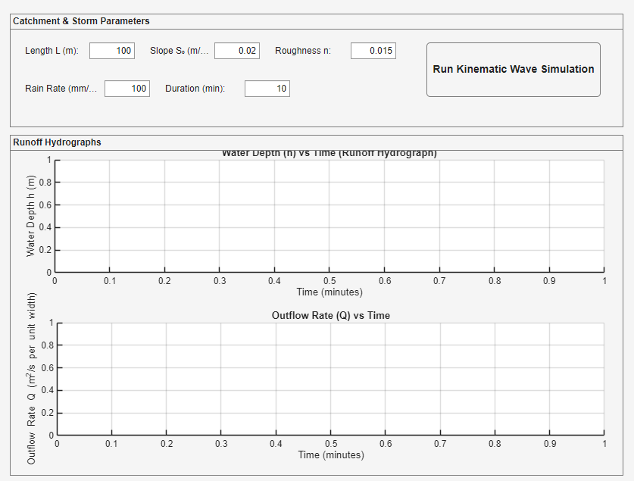
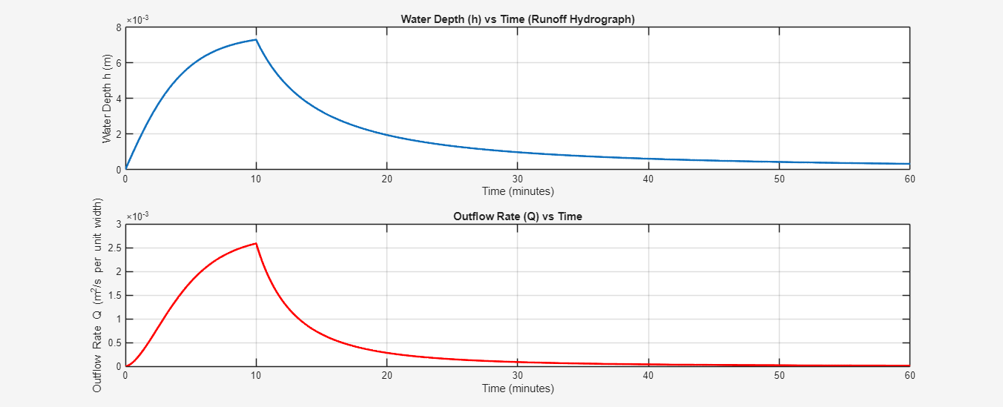

CONCLUSION
In conclusion, this work has successfully bridged theoretical numerical analysis with practical engineering applications, demonstrating that well-designed software frameworks can significantly enhance both the development process and the end-user experience in computational engineering. The resulting system stands as a testament to the power of integrating sound software engineering practices with advanced mathematical modeling to address complex real-world challenges in water resources engineering and beyond.

